Austin Stephens

Assignment 07

3/28/17

1. My program successfully creates a structure called Employee, and then allocates enough memory to create an Employee array. The user then inserts the names and salaries of the three employees. Then the program prints all of the information, increases the salaries ten percent, and then prints all the information again

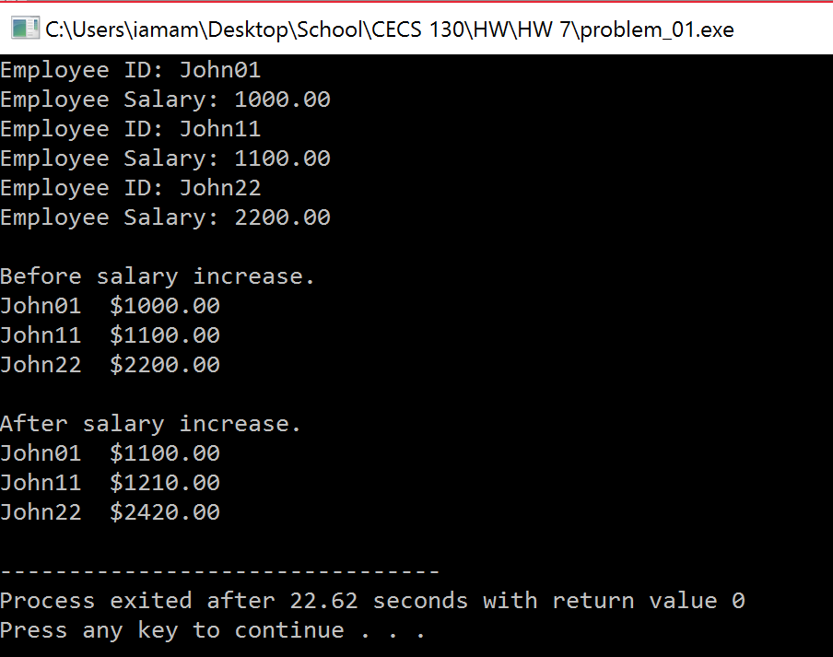

1. My program successfully calls on the function loadMySongList which opens a file called mySongsList and then prints all the songs in the file.

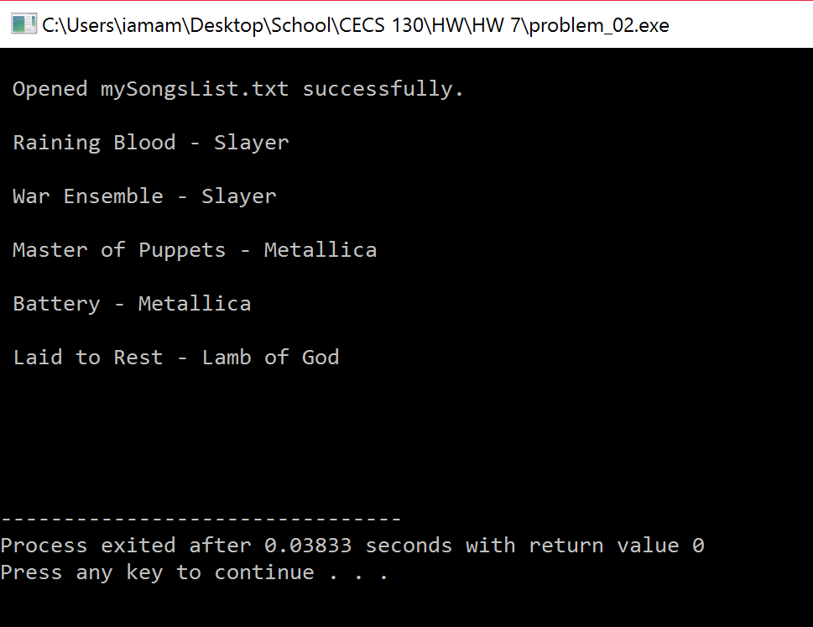

1. My program successfully creates a file name myBooksList and then writes the names of two books into it. It also prompts the user that the file was opened successfully.

